RAT Magazine October 2009
Introduction
Welcome to the October edition of the Kippax Harriers newsletter. There are race reports, photos and results to follow. There is also another club championship standings update and all the usual news of upcoming social events.

Race Reports

1. Amsterdam Half Marathon – 16th October 2009 (Mariah Elmiah)

Well, I never expected that I would be writing a race report! Apparently there’s a first time for everything.

But following a dismal Leeds half marathon time of 3.22.06 (I was poorly), I thought things could only get better in Amsterdam. And if they didn’t, I’d at least have had a holiday.

Everything went according to plan for the trip. Thanks to Val’s organisation and Running Crazy, we arrived early on Friday and settled in at the hotel. We visited the expo that day (hard to find, and not much worth buying), followed by a meal at an Egyptian restaurant, where Kippax Harriers were kept separate from the rest of the diners. (Did they know we were going to tell risqué jokes all night?). There were trips around Amsterdam on the Saturday, and an Italian meal in the evening.

The great day dawned, rather warmer than the marathon runners would have liked with a 10.30am start for them. The half marathoners were there to cheer them off, before retiring back to the hotel to prepare themselves for the 2pm start for their own race. There were reports (true) of 2 Kippax ladies stripping, to take off the t- shirts they were wearing under their vests due to the heat.

There’s not a lot you can say about the course. It’s flat. (As one who dies on the hills, it’s the reason I chose that particular race). It was cooling down by 2pm, and we had fairly perfect conditions, considering the windy Friday and warm Saturday we had already experienced. The last part of the course was through the Vondelpark, and into the Olympic Stadium for the finish. I like to think I surprised the rest of the Kippax crew by arriving so shortly after the rest. I certainly surprised myself! The time? 2.22.11, only 5 seconds off a full hour better than in Leeds (I told you I was poorly then).

There was another meal out at an Irish pub, where there were presentations, including one for the most improved half marathon time. Dear reader, I was the recipient (thanks Val).
This was followed by a walk through the red light district, and so to bed. Back in our own hotel rooms, I hasten to add.

Ann Martin’s husband, Steve, was honorary lady, and official photographer for Kippax ladies. There was much hilarity and jollity during the weekend, and all agreed that with good runs (even for those who were carrying injuries, and who still had the cheek to finish before me) and good company, it had been a most enjoyable and successful weekend. Maybe same time, same place, next year!

Results

Marathon:

First Male Gilbert Yegon 2:06:17
First female Eyerusalem Kuma 2:27:42

Kippax Harriers
Val Pell 4:07:41
Simon Mustill 4:07:55
Kate Penrose 4:12:55
Ann Martin 4:49:59

6902 Finishers

Half marathon:
First Male Jonathan Frost 1:10:49
First Female Katriens Goossens 1:17:46

Kippax Harriers

Jane Mustill 1:58:21
Kate Kidd 2:00:11
Samira Lambert 2:00:37
Wendy Chapman 2:00:53
Sue Holmes 2:05:22
Moira Lenaghan 2:08:39
Kelly Palmer 2:13:19
Joyce Robinson 2:20:49
Maria Elmieh 2:22:11

9024 Finishers

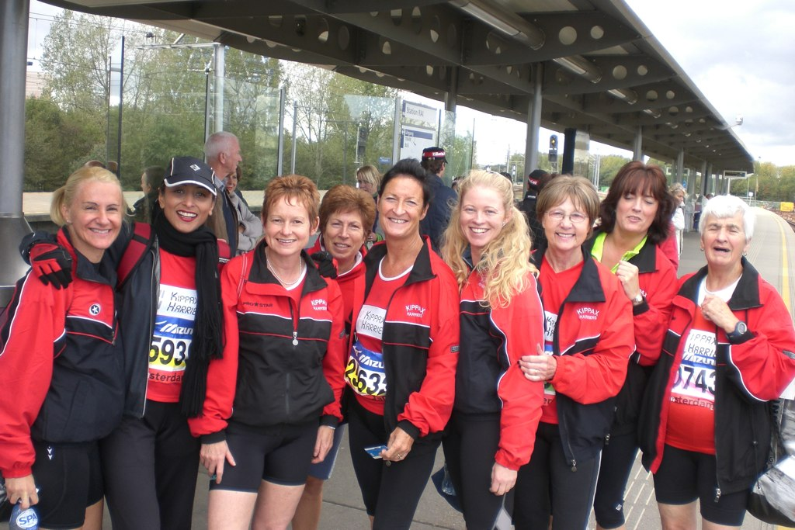

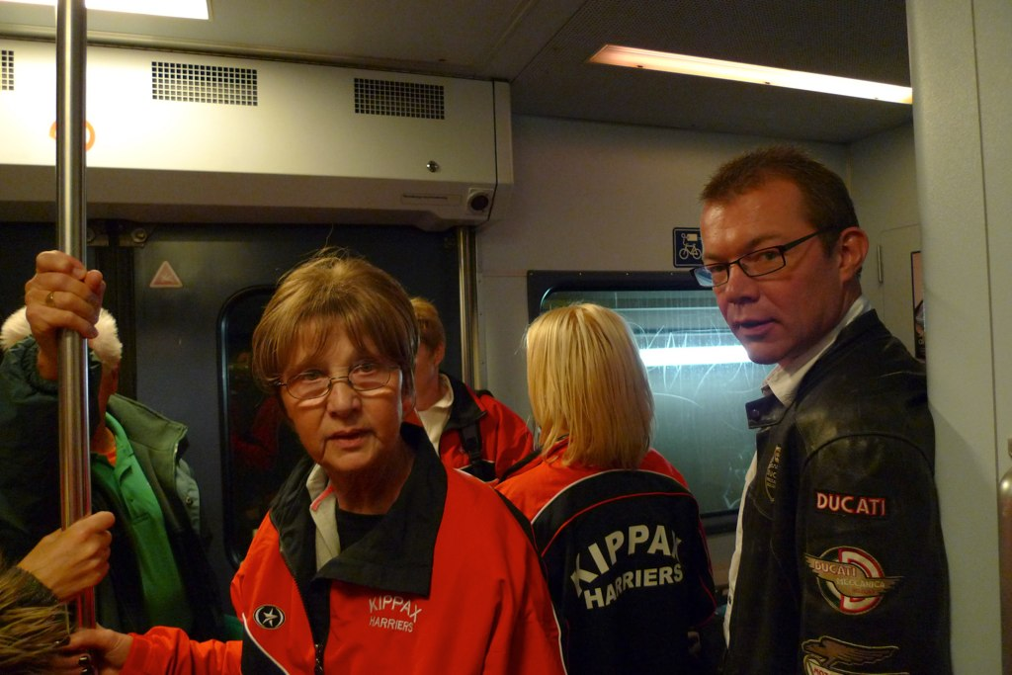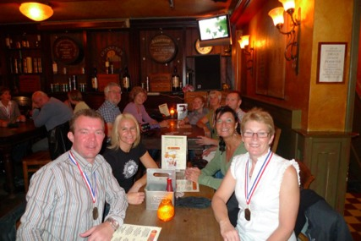
A speechless Joyce. A collector’s item? Well deserved celebrations.

(Ed: Well done to all of the Harriers in Amsterdam. There were some good performances there and it sounds like you all had a good time as well. Special congratulations to Simon on completing his first marathon. Judging by the times his plan of trying to stay with Val seems to have worked like clockwork. Many of you may not be aware that Simon had a particularly nasty fall from his bike a couple of months ago which severely disrupted his training. Following that accident, he sported the largest and most colourful looking bruise I’ve ever seen.)

2.Pickering & Moors 10k 25th October 2009 (Craig Worley)

So much for the weather forecast. We were promised a fine mild day. What we got was a blustery one with heavy showers thrown in for good measure. But that didn’t deter the 11 Harriers who turned up at St Joseph’s School Pickering, for this pleasantly low key race.

This is definitely not a PB 10k course. For one thing in distance it’s more like 10.3K. This must have been quite disconcerting for those who’d not run the race before when arriving at the 10K marker and discovering they’d not actually finished. For another, it’s quite hilly with a steady climb up to the half way point. Finally, about 40% is off-road, on tracks and round a particularly muddy field. This presents a bit of a dilemma when considering footwear choice. Most people plumped for road shoes including yours truly. I was beginning to regret this while slipping and sliding on said muddy field and a fellow runner in Roclites sailed gracefully past me. Still, I caught him up and passed him on the downhill road section that followed. Ha!

Two years ago, when we last did Pickering & Moors as part of the club championship, thick fog obscured much of the views. It was scarcely better this time with all that wind and rain. But I would imagine on a crisp sunny autumnal morning, this countryside race would be a hidden gem. To crown it, all finishers were rewarded with free cake at the end back at the school.

Finally, well done to Val, Ann & Kate P for doing this race only a week after their marathon efforts in Amsterdam. Not forgetting Kate K, Wendy, Sue and Kelly who’d done the half.

Results
First Male – Andy Whitworth – Meltham AC 36:52
First Female – Rowan Johnson - Scarborough AC 41:08

Kippax Harriers
13 – Craig Worley 44:33
20 – Nick Thorp 46:48
53 – Jay Kitchen 51:51
72 – Carole Kitchen 55:18
74 – Val Pell 55:44
87 – Ann Martin 57:27
94 – Kate Penrose 58:38
97 – Kate Kidd 58:44
103 – Sue Holmes 1:00:44
109 – Wendy Chapman 1:01:50
121 – Kelly Palmer 1:05:46

136 finishers

Other Results

1. Harewood 10 mile Trail Race – 4th October 2009
First Male – Andrew Pearson – Longwood Harriers 52:49
First Female – Karen Pickles – Pudsey Pacers 1:06:31

Kippax Harriers
72 – Martyn Hewitt 1:11:08
91 – Allison Skillicorn 1:12:13
133 – Leanne Hague 1:15:56
320 – Val Pell 1:27:52
409 – Carole Kitchen 1:34:36
438 – Kate Penrose 1:36:53
456 – Kate Kidd 1:38:05
500 – Kelly Palmer 1:40:53

566 finishers

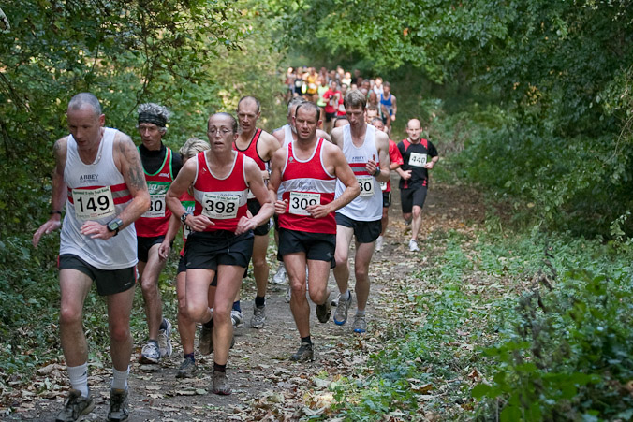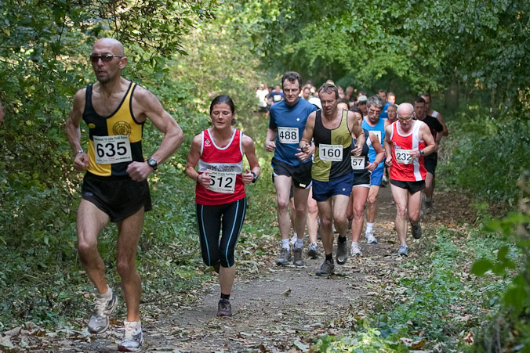
Allison & Martyn battle it out. Leanne in deep thought.

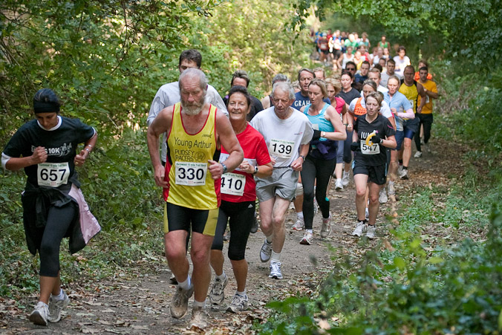
Kelly seems to be enjoying herself.

Photos courtesy of David S Brett.
http://www.photos-dsb.co.uk/harewood%20trail/index.html

2. Bridlington Half Marathon – 18th October 2009

First Male – Andrew Pearson – Longwood Harriers 1:05:48
First Female – Helen Cross – Pocklington 1:22:44

Kippax Harriers
184 – Nigel Mckaine 1:38:45
365 – Tracey Mckaine (new member) 1:51:06

684 finishers

Club championship update

Things have changed a bit since last month. You may recall that there was barely a hair’s breadth between Val and Wendy. Sadly for Wendy, injury has struck at the most inopportune of moments (there is never a good time). As a consequence Val has surged ahead leaving only Carole in hot pursuit.

In the ladies championship things are a lot tighter and thanks to Carole’s narrow victory over Val at Pickering she now holds a slender one point lead.

As for the men, things are just as tight with with Nick and me currently vying for top spot. In third, after Pickering Jay has nosed ahead of Martyn.

For those of you who might be wondering, I’m not picking on Kelly honestly. Because she has done more than the maximum eight races that count I’m deducting the points from those races where she scored the least points. So it’s worth remembering, if you’ve now done eight races by carrying on doing races you can still add to your tally by having your worst performances removed.

Handicap League

 |  |  | Position after Horsforth | Harewood Trail | Pickering 10K
Handicap | Name |  |  | 10 | 11 | TOTAL | RACES | ADJUSTED PTS
51.00% | Val Pell | L | 105 | 20 | 19 | 144 | 8 | 144
50.00% | Carole Kitchen | L | 96 | 16 | 18 | 130 | 8 | 130
50.00% | Wendy Chapman | L | 104 | 0 | 10 | 114 | 7 | 114
53.00% | Kelly Palmer | L | 99 | 15 | 11 | 125 | 10 | 110
50.00% | Ann Martin | L | 91 | 0 | 17 | 108 | 7 | 108
51.50% | Sue Holmes | L | 91 | 0 | 16 | 107 | 7 | 107
55.00% | Kate Kidd | L | 59 | 18 | 20 | 97 | 6 | 97
33.00% | Craig Worley | M | 79 | 0 | 14 | 93 | 6 | 93
35.00% | Nick Thorp | M | 69 | 0 | 12 | 81 | 6 | 81
42.00% | Leanne Hague | L | 61 | 19 | 0 | 80 | 5 | 80
48.50% | Kate Penrose | L | 47 | 13 | 13 | 73 | 6 | 73
38.00% | Allison Skillicorn | L | 47 | 17 | 0 | 64 | 4 | 64
43.00% | Jay Kitchen | M | 48 | 0 | 15 | 63 | 5 | 63
39.00% | Rob Kelly | M | 60 | 0 | 0 | 60 | 4 | 60
52.00% | Michelle Duff | L | 60 | 0 | 0 | 60 | 4 | 60
32.00% | Martyn Hewitt | M | 46 | 14 | 0 | 60 | 4 | 60
42.50% | Nigel Mckaine | M | 55 | 0 | 0 | 55 | 3 | 55
39.00% | Steve Devney | M | 35 | 0 | 0 | 35 | 3 | 35
40.00% | Tony Blythe | M | 34 | 0 | 0 | 34 | 3 | 34
33.00% | Gerry Waterton | M | 19 | 0 | 0 | 19 | 1 | 19
50.00% | Moira Lenaghan | L | 18 | 0 | 0 | 18 | 2 | 18
55.00% | Derek Morris | M | 17 | 0 | 0 | 17 | 1 | 17
52.00% | Samira Lambert | L | 16 | 0 | 0 | 16 | 1 | 16
53.00% | Jane Mustill | L | 15 | 0 | 0 | 15 | 1 | 15

Ladies’ overall championship

 |  | Position after Horsforth | Harewood Trail | Pickering 10K
Name |  |  | 10 | 11 | TOTAL | RACES | ADJUSTED PTS
Carole Kitchen |  | 108 | 17 | 20 | 145 | 8 | 145
Val Pell |  | 107 | 18 | 19 | 144 | 8 | 144
Wendy Chapman |  | 111 | 0 | 14 | 125 | 7 | 125
Ann Martin |  | 106 | 0 | 18 | 124 | 7 | 124
Kelly Palmer |  | 110 | 14 | 13 | 137 | 10 | 113
Sue Holmes |  | 94 | 0 | 15 | 109 | 7 | 109
Kate Penrose |  | 67 | 16 | 17 | 100 | 6 | 100
Leanne Hague |  | 79 | 19 | 0 | 98 | 5 | 98
Kate Kidd |  | 57 | 15 | 16 | 88 | 6 | 88
Allison Skillicorn |  | 60 | 20 | 0 | 80 | 4 | 80
Michelle Duff |  | 62 | 0 | 0 | 62 | 4 | 62
Moira Lenaghan |  | 29 | 0 | 0 | 29 | 2 | 29
Samira Lambert |  | 18 | 0 | 0 | 18 | 1 | 18
Jane Mustill |  | 13 | 0 | 0 | 13 | 1 | 13

Men’s overall championship

 |  | Position after Horsforth | Harewood Trail | Pickering 10K
Name |  |  | 10 | 11 | TOTAL | RACES | ADJUSTED PTS
Craig Worley |  | 97 | 0 | 20 | 117 | 6 | 117
Nick Thorp |  | 96 | 0 | 19 | 115 | 6 | 115
Jay Kitchen |  | 67 | 0 | 18 | 85 | 5 | 85
Martyn Hewitt |  | 59 | 20 | 0 | 79 | 4 | 79
Rob Kelly |  | 73 | 0 | 0 | 73 | 4 | 73
Nigel Mckaine |  | 57 | 0 | 0 | 57 | 3 | 57
Steve Devney |  | 51 | 0 | 0 | 51 | 3 | 51
Tony Blythe |  | 50 | 0 | 0 | 50 | 3 | 50
Gerry Waterton |  | 20 | 0 | 0 | 20 | 1 | 20
Derek Morris |  | 17 | 0 | 0 | 17 | 1 | 17

Forthcoming races

Club Championship races

The next club championship race is the Guy Fawkes 10 on 1st November. It’s just a gentle little meander I seem to remember……nothing to worry about. Seriously though, it’s a great race, finishing in the splendid surrounds of Ripley Castle. And did I mention that goody bag!

Kit news

The club has ordered some Kippax Harriers t-shirts. They are black with a red club logo. See Maria to try out for size as she has some samples.

Social Events and other news

- There will be a Christmas Quiz club run on Thursday 10th December – questions to be set by Wendy. Then it’s back to the club for the results and Chilli & Jacket potato followed by mince pies.
- This year's Christmas Party is at the Quality Hotel on the old A1 just off the A63 on Friday 18th December. There will be a sit down meal and a disco. The full price is £18.75 but the club will be providing a subsidy of £8.75 for all members/social members. If you would like a ticket then please see Val with your money (or another committee member) by the 5th November.
- Congratulations to Gary & Mel for completing the Wild Boar Challenge Bike Ride on the 4th October. This is a 50 mile off-road cycle through parkland, woods, on canal towpaths and cycle paths. The guys finished in around three hours.
- A big thank you to Wendy for inviting us all to her 50th Birthday bash this month at The West Riding County FA. There were many Harriers in attendance and a good night was had by all.
- As many of you will be aware, the club is awarded two London Marathon places each year. The draw from the unsuccessful members who’d tried to get in through the normal ballot was made at the last committee meeting. The lucky winners were Jonathan & Wendy with Val as reserve.
- It was also suggested at the last meeting that we have a Runner’s Runner of the Year. This would give everybody a chance to vote for somebody else in the club (we thought voting for yourself might not be quite in keeping with the spirit of things). There would be no set criteria to make your choice upon. It’s up to you. But for example you might want to consider commitment to the club, a willingness to help others in training, giving lifts to races, ability to consume the most pies (we know who’d win then) etc. Voting slips will be available nearer the time including at the Christmas “do”.

Runner of the month
This month it’s ME - hurray! ........oh and Martyn as well.

Apparently the joint award is for our 3:17 in last month’s Nottingham Marathon. Seriously, thank you to Martyn for sticking with me when I’m sure he could have gone faster and for kindly informing me at 24 miles that my pace was dropping.

I did receive a bottle of red wine, I’m sure it was very nice but the wife got there first before I had chance to drink it. Damn, I really must be quicker off the mark.

That’s all for this month – Please send your contributions for the November issue to worleyc@sky.com.

