STAC XC Virtual League – Micklefield

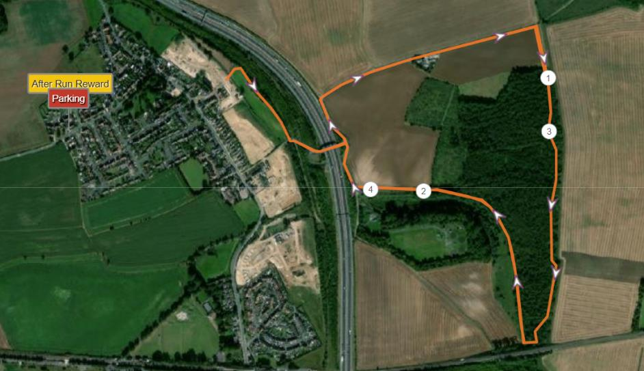

A Course: 4.4 Miles (2 Laps of Hartly Woods) https://www.strava.com/segments/26581832
B Course: 2.5 Miles (1 Lap of Hartly Woods) https://www.strava.com/segments/26614156

A Course (PlotaRoute) https://www.plotaroute.com/route/1355340

B Course (PlotaRoute) https://www.plotaroute.com/route/1355342

Suggested parking just off Church Lane on the Left as you enter Micklefield otherwise street park where safe to do so.
After run completion “prize” available for STACs in the garden of my house – 3 Sunningdale, LS25 4AZ
Run anytime in January

Parking and Route to Start
There is a Small Car park behind the bus stop on the left hand side of road as you enter Micklefield – postcode LS25 4AZ will get you here. If this car park is full take the next Left into Sunningdale and then left again and there should be some space behind my car on the left.
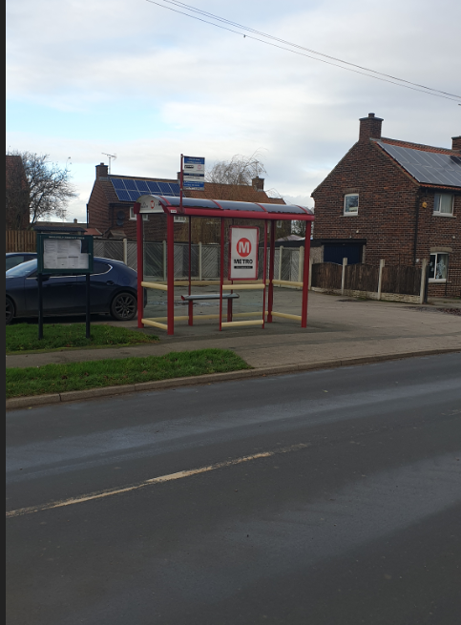
From the car park walk downhill towards the church and then at the T Junction take a RIGHT onto Great North Road
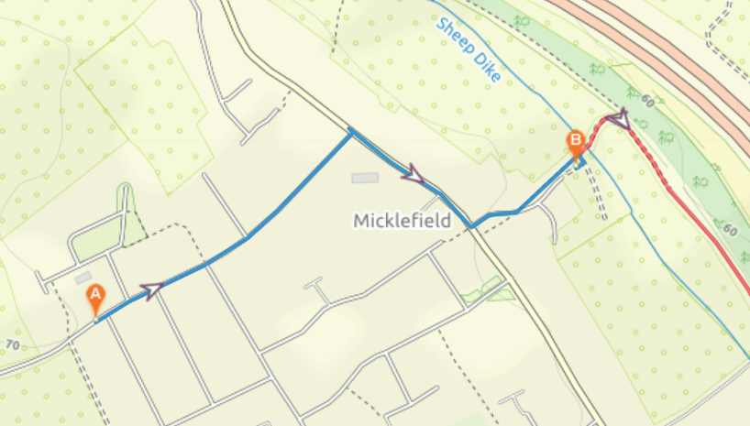
Carry on until you see a Plough and the Milestone and here take a LEFT into Grange Farm Court

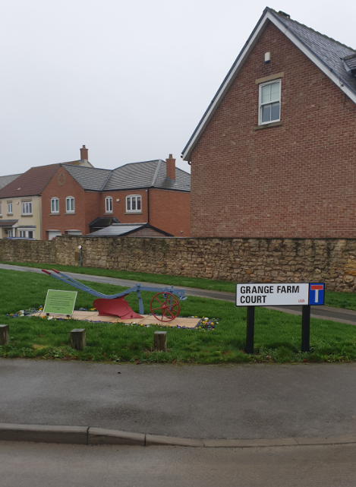

The Start is by the gate at the bottom of the hill)

The COURSE
Start and Finish – Gate at the bottom of Garth Farm Court
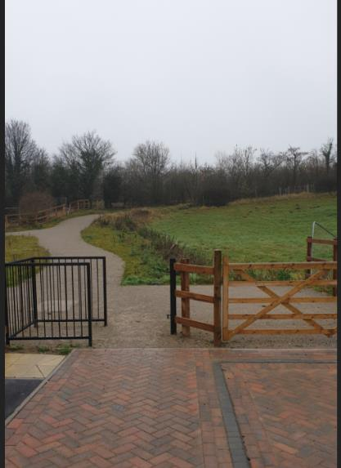
Climb up the hill and then continue on the path as it bears to the RIGHT (do not go through the small wooden gate by the bench)
This nice little rollercoaster (up and down) will drop you out onto a tarmac road – here you will turn LEFT (be very careful of traffic)

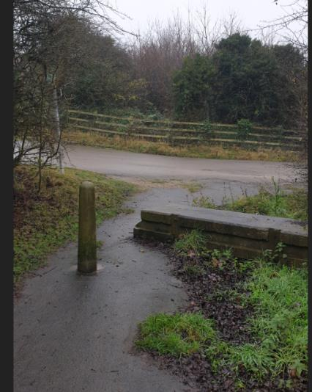
Did I mention climbs well here’s another one – on the tarmac road continue up the hill and over the A1 and you will then see a yellow Kennels and Cattery sign at a road junction
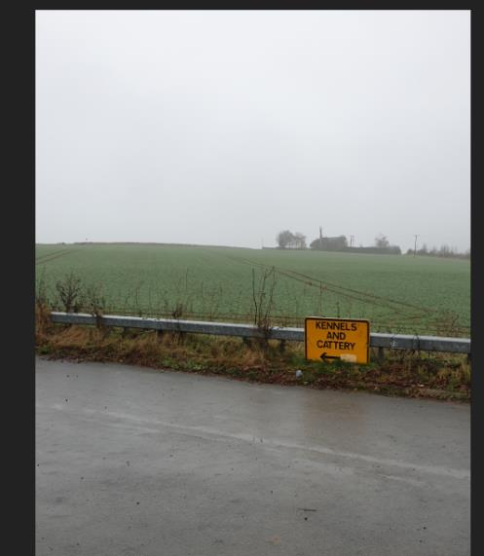
If you look up here you will see the Cattery on the horizon and this is the next destination
Turn LEFT at the yellow sign down a small descent and then climb up to a bend in the road.
Follow the road as it bends round to the RIGHT (do not go through the barrier)
Continue up the hill until you get to the Cattery and take the grassy path on its Left hand side
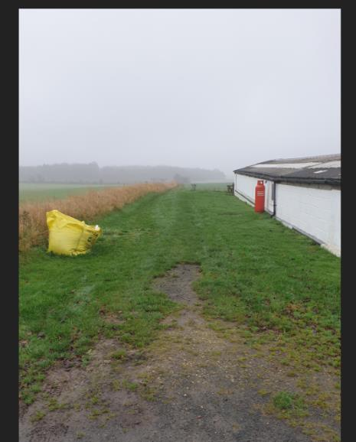
Continue slightly downhill, down the side of the field until you see a footpath finger post and double green bench. Here you need to turn RIGHT (signposted as Huddlestone) and head up the hill towards the forest (Hartly Woods)
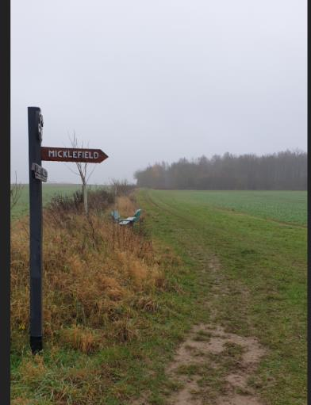
Enter the woods and go straight on, the path undulates a bit here so watch your footing. There are a number of small paths off to the right but ignore all these. You will eventually come out onto a big path junction by a bench
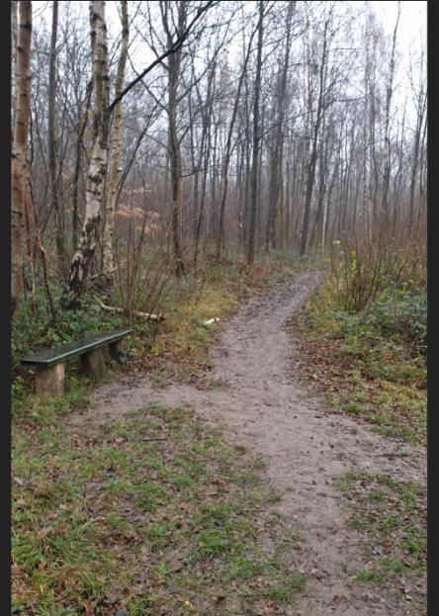
AT this junction continue STRAIGHT ON – ignore the path to the right
Now we have the muddy and slippery bit for the next 500 metres
After the worst of the mud the path will now go down a hill (be careful of footing) and you will see two shelters on your Left hand side.
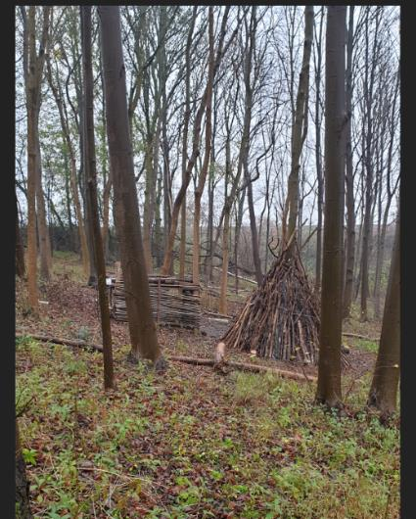

Just past these the path will bend to the RIGHT and then flatten out. Here you need to take a RIGHT turn onto a small path (do not go over the bridge)

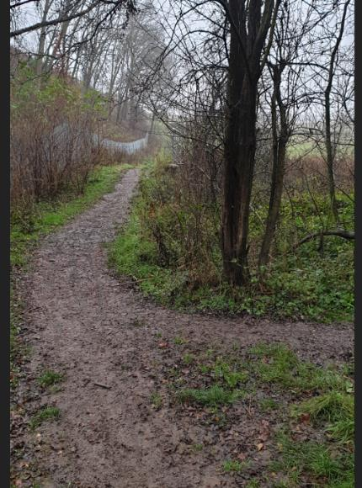
From here you will follow the Sheep Dyke stream and old hedge boundary. Ignore a small bridge to the Left and continue on to pass the highly impressive Micklefield Waterfall
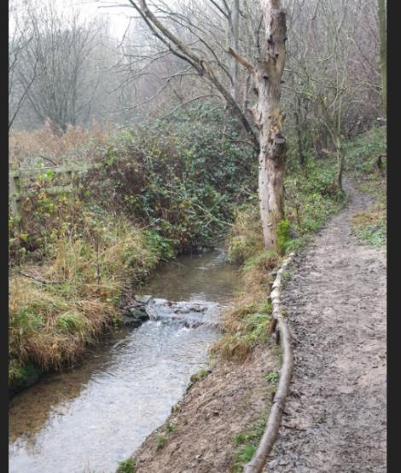
Continue straight on and you will soon see Micklefield Loch on your left (I’m calling it this as it isn’t named on the OS maps)
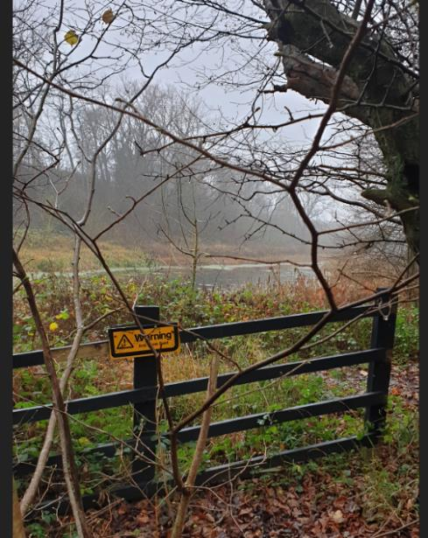

Shortly after this, the path slightly rises and you will come out onto a grassy track by a large tree. Turn LEFT onto the track

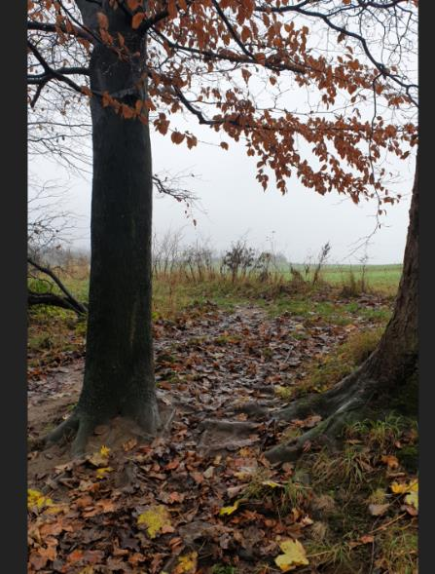
Continue straight on this track until it drops you out onto a tarmac road.
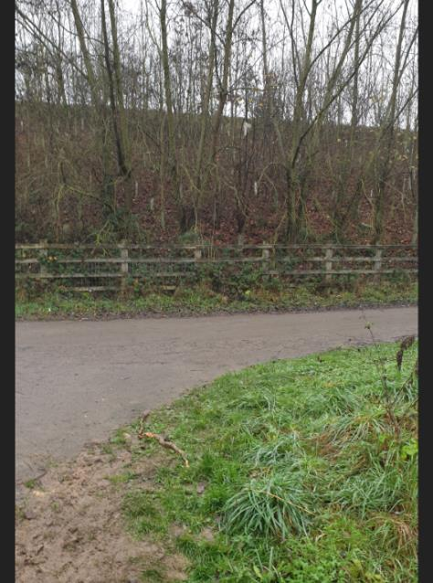
Turn RIGHT and go up the Hill (Strava Segement) until you get back to the Yellow Kennels and Cattery Sign
If you are doing the A Course go back up the hill past the Cattery and through the woods again.
Having now completed your 1 Lap (B Course) or 2 Laps (A Course) – it is time to go to the finish
Head back over the A1 on the Bridge
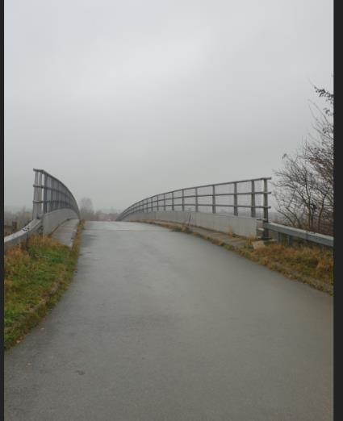
Be very careful here with traffic as you may not hear them due to the noise of the A1
Head down the hill and then take a LEFT to go back onto the small roller coaster incline path
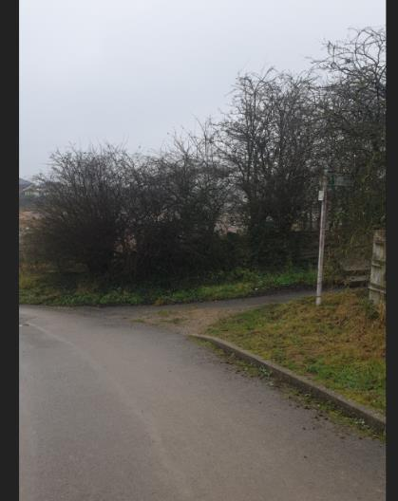
After running through the woods and up and over the A1 this last incline will HURT but it is soon over and you have a small downhill back to the gate and the finish
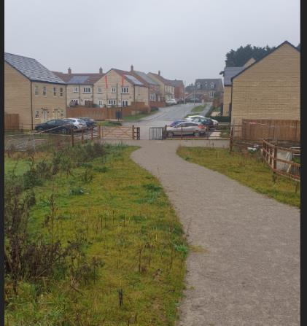

Run done head back up to where you parked your car. For the STAC members make sure to pop into the garden of number 3 Sunningdale (my house) for your completion prize. I’ll post details of what it is and how to collect it closer to the time.

